Upgrade a Shadow File from ICD-10-CA/CCI v. 2012 to ICD-10-CA/CCI v. 2015

To upgrade either (or both) a v. 2012 ICD-10-CA or CCI Shadow File to the corresponding v. 2015 classification, follow the instructions outlined in the **Upgrade Shadow Process** sectionbelow**.**

**Upgrade Shadow Process**

1. Ensure v. 2012 ICD-10-CA/CCI is installed.
2. From the Start Menu shortcut, open the v. 2015 classification as a Shadow File **.SDW** (either ICD-10-CA or CCI) for which you want to upgrade a v. 2012 Shadow File. Do not open the v. 2015 Infobase (.NFO).

* Folio Views will launch with the appropriate customizations for the specific classification (ICD-10-CA or CCI).
  + The first time you open the v. 2015 .SDW, a “new” v. 2015 Shadow (.SDW) File containing no Notes, Highlighters, or Bookmarks will be loaded. It is ready for you to Upgrade with your v. 2012 Shadow File.

In the classification, when you click on the Tools button, Upgrade Shadow in the dropdown menu should be active (i.e. not grayed out). If it is grayed out, you will need to ‘modify permission’ to allow you to have read/write permission in the v. 2015 Shadow File (.SDW). Please contact your IT department to do this for you otherwise you can follow the instructions below.

***Modify Permission***

Make sure wherever the installation is located that it is read/write. For the default location, go to your c:\ drive, right-click on the CIHI folder (or the folder where you installed the v. 2015 classifications), click on “Properties”, go to Security tab and make sure users have modified permissions. (see below)

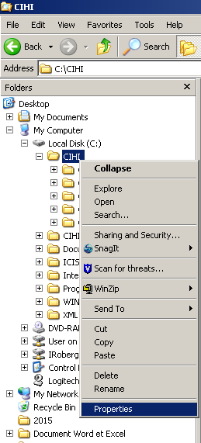

When in the Security tab in the CIHI Properties box, click on the Users group under the “Group or user names:” header. If the modify box, under Permissions for Users, is checked then you have full read/write permissions and can use the upgrade shadow function. If the modify box is not checked then you only have read access and the upgrade shadow feature will not be available.

If your upgrade Shadow File feature is grayed out the permissions to the installation folder will look like the screenshot on the left. After checking the Modify box and clicking apply, the screen shot on the right will allow you to use the Upgrade Shadow feature.

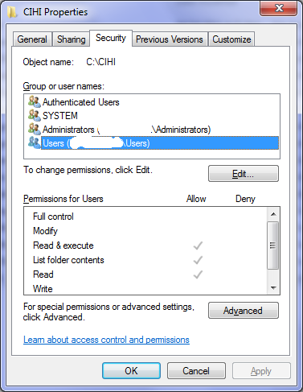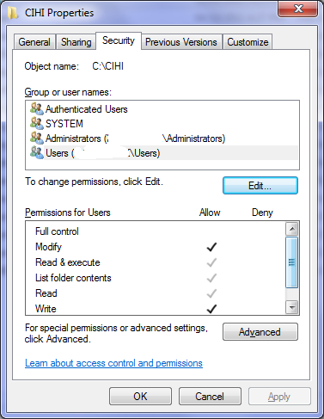

You are now ready to Upgrade your v. 2012 Shadow Files to the v. 2015 classifications.

**To start the new Upgrade Shadow process:**

1. Click the “Tools” menu

* select “Upgrade Shadow”

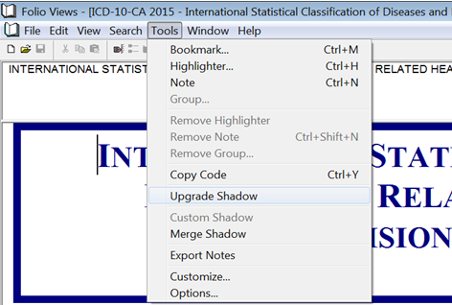

1. On the prompt, ‘browse’ to locate your v. 2012 Shadow File that you want to upgrade for use in the v. 2015 classification.

* Click “Open”.

**Note:** Ensure when you open the v. 2012 Shadow File classification that it is the same classification as the v. 2015 classification that you have open – for example, upgrade the English CCI 2012 Shadow File to the English CCI 2015 .SDW.

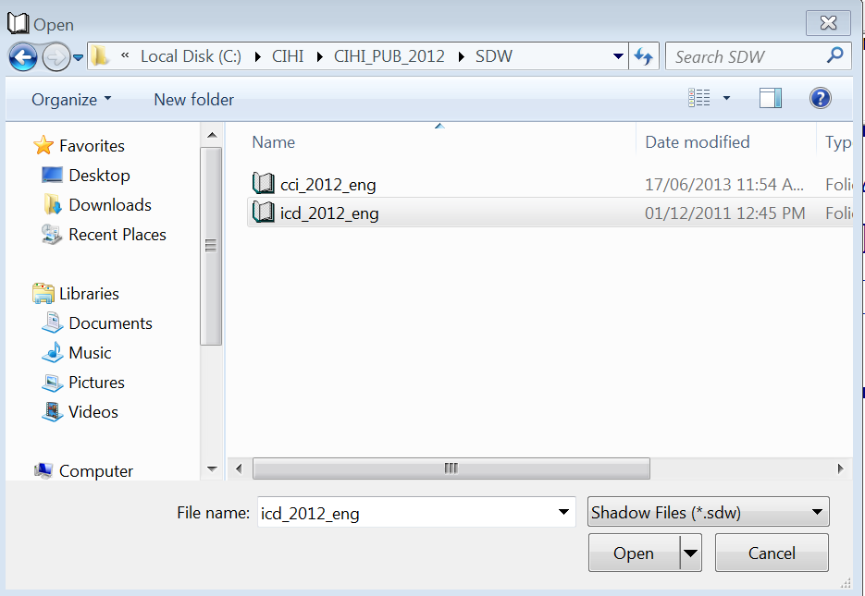

* The “Upgrade Shadow” process will begin, showing a Progress dialog. There is no further action required during the Upgrade Shadow process.
* After this process is complete, a log file will appear. (see the example of a log file below)
* Save the log file in a desired location for retrieval purposes. This is a one-time process; therefore, you do not have to repeat this every time you open the v. 2015 ICD-10-CA/CCI shadow files. If you do not want to save the log file you can repeat the Upgrade process as often as you wish.
* For details on what is included in the log file, see ‘Analyzing the Log file’ below.
* This completes the process for upgrading your v. 2012 Shadow File to v. 2015.

1. Repeat steps 1 – 4 for other v. 2012 Shadow Files you want to upgrade to a v. 2015 classification.

***Log file example:***

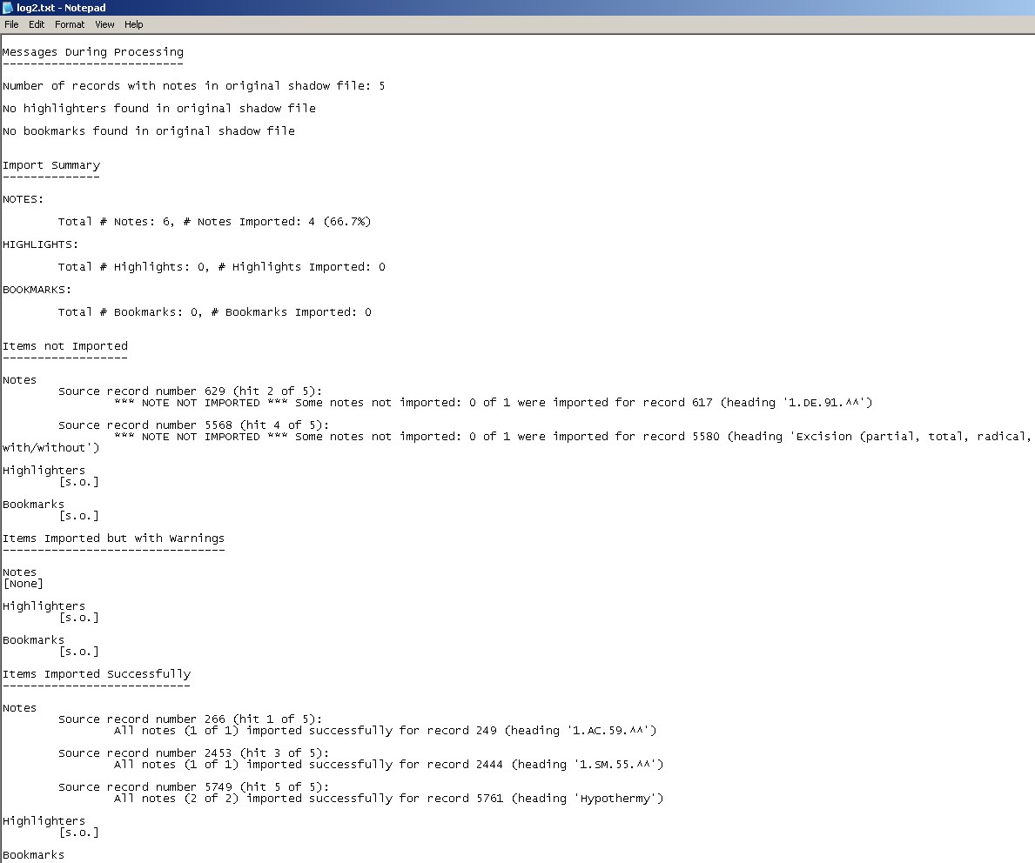

***Analyzing the log file***

The log file provides a summary of the Upgrade Shadow File process indicating whether or not the import of each note, highlight and bookmark was successful.

**Note:** The Upgrade Shadow File process may not automatically copy 100% of the notes, highlighters or bookmarks. For example, where a code was deactivated in v. 2015, the v. 2012 Shadow File note would not have a location in v. 2015. It is important that you review each item in the “Items not Imported” and the ‘’Items Imported but with warnings’’ sections of the log file and take manual corrective measures if desired.

For entries that were not imported, you should locate it in your v. 2012 Shadow File and attempt to find a suitable location in the 2015 Shadow File, using a process similar to the following:

* Open your v. 2012 Shadow File
* Open the v. 2015 Shadow File for the same classification
* Review the “Items not Imported” section of the log file then, in your v. 2012 Shadow File, locate each item that was not imported into the v. 2015 Shadow File. See “Searching for notes that did not Import or Import with warnings to the v. 2015 Shadow File” below.
* Examine the contents of the note in your v. 2012 Shadow File that was not imported to the v. 2015 Shadow File to determine its suitability for inclusion in the 2015 file.
* If you determine that the item from your v. 2012 Shadow File that was not imported to the 2015 file has relevance in the 2015 classification, search for similar codes or text in the v. 2015 Shadow File where the note from 2012 can be located. Examine the “Deactivated Codes” appendix in the 2015 classification to determine whether or not the code has been intentionally removed.
* To copy a note from your v. 2012 Shadow File to the v. 2015 Shadow File, open the 2012 note, copy the text to a Word or Excel document, then copy and paste the text into a new note that you manually created in the v. 2015 Shadow File.
* Bookmarks and highlighters that have not been imported can be manually reapplied to the v. 2015 Shadow File using the Folio “Bookmarks” and “Highlighters” functionality.

Note: Reasons an item may not be imported (or imported with warnings):

* The code was deactivated in v. 2015 ICD-10-CA/CCI and there is not a suitable location for the item from the 2012 version; and
* The Upgrade Shadow File module attempts to find the most suitable location where the entry should be placed however some items may be ambiguous and a specific location cannot be found. It is important that you review the “Items not Imported” section of the log file to review each item that was not imported and take manual corrective measures if desired. Also in ambiguous situations, the module may select a specific location. Review the ‘’Items Imported but with warnings’’ section of the log file and take a look at each possibility to determine if the best location has been chosen. If the entry is not in the v. 2015 Shadow File, you may decide to copy the note manually, or ignore the item and not insert it in the v. 2015 Shadow File.

***Searching for notes that did not Import or Import with warnings to the v. 2015 Shadow File***

* Open your v. 2012 Shadow File;

Click on the Go To button;

Click the Record Number button;

Enter the Record number from the Items not Imported or Imported with warnings in the log file in the Go to field

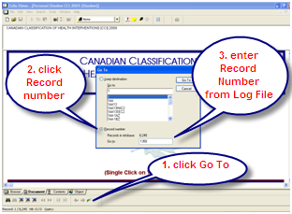*Example:*

*Items not Imported*

*Notes:*

*Source record number 1350 (hit 1 of 5):*